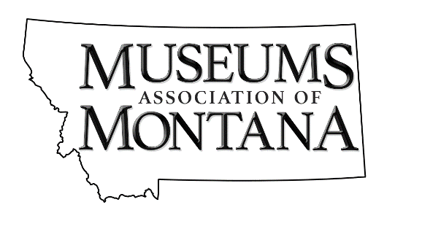
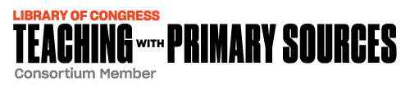

Home Waters: Primary Sources and the Places of Montana

INTRODUCTION

Home Waters: Primary Sources and the Places of Montana will create partnerships between museum staff and public-school teachers to support the use of primary sources, literature, and place in the classroom and museum setting. Participants will gain knowledge about the place where they are living, and how it fits into the larger perspective of Montana, connecting museums and classroom learning, and strengthening community learning partners and providing a place-based educational program that can be integrated into classrooms in Montana and across the nation.

This project will be fiscally sponsored by the Library of Congress and the Museums Association of Montana which is a nationally recognized National Endowment for Humanities partner and non-profit organization whose goal is to strengthen all of Montana's Museums and provide interpretive and educational experiences to those who visit Montana, or those that want to learn more about Big Sky Country. The Museum Association of Montana accomplishes this by supporting their efforts to collect, preserve, and interpret our shared heritage for all Montanans and our visitors. By furthering the missions of Montana’s museums through collaboration, the promotion of standard best practices, grant-sponsored projects, and advocacy on the local, state, and national levels, we will ensure the preservation of our rich history.
The ultimate goal is to promote a sense of place and understanding of Montana history, past and present, through increased collaboration among Montana’s museums, schools, teachers through sharing of the new book by John MacLean, “Home Waters”.

GRANT AMOUNTS AVAILABLE

The Museums Association of Montana in partnership with the Library of Congress will provide $750 stipends to selected Museum/Educator partnerships (applicants).

PRIORITIES/PROJECT GOALS

- Connect a new piece of acclaimed literature “Home Waters”( and a well-known familial companion “A River Runs through It”) with primary sources that can be analyzed and studied by students or community members so that a deeper understanding of the book may be had when reading it.
- Provide the opportunity for Scholar to Teacher connection questions, support research, and understand the books “Home Waters” and “A River Runs through It” and how they play a role in understanding key places, in Montana but in other places as well.
- Provide explicit Library of Congress training for participants (teachers and museum staff) about searching the deeper collections of the Library of Congress (as well as other archives) and how resources in the collections can expand an understanding of places that appear in literature and history and provide connections to state and national standards in multiple disciplines.
- Provide educators and local museum partners with an opportunity to connect, partner in an inquiry process, and develop a plan at how to use local museum primary and secondary sources in concert/partnership with schools to embed the study of place and heritage in the classroom. This project allows for an avenue not only to foster partnerships using primary sources and literature but to build sustained relationships for ongoing collaboration.
- Share the mission of the project through virtual communication and presentations with a wider audience including the American Association of State and Local History, The National Council for Social Studies, National Council of Teachers of English, and other educational entities such as the Montana Education Association, the learning cohorts in participating school districts, and curriculum specialists in the state of Montana.

CONDITIONS OF PARTICIPATION

- All museums must be 501c3 Non-profit organizations in good standing.
- All participant teams must be made up of one non-profit museum and a K-12 educator.
- All participants must be willing and able to attend all six Web Meetings.
- All participants must commit to completing a measurable project utilizing the skills and resources identified through the Home Waters Project.

GRADING
10% - completeness of application
20% - track record of demonstrated ability to collaborate with other like-minded organizations.
40% - Ability to fully answer and explain the grant questions below.
30% - the long-term benefit of the product/project to the community

AWARDS SCHEDULE

Application Deadline: July 15, 2021
Earlier submission is recommended.

Applications will be reviewed and prioritized by a selection committee. Selections will be made and approved partnerships notified by August 1st, 2021

APPLICATION

Name of Project:
Name of applying museum:
Organization representative:
Address:

Telephone: Fax: ________________________
E-mail: Website: ______________________

Name of partnering educator___________________________________________
School District ______________________________________________________
Address:

Telephone: Fax: ________________________
E-mail: Website: ______________________

- Please feel free to submit your answers below, or as a separate attachment.

Why is your Museum/Educator interested in this project?:
______

How will your community benefit from a collaboration between your local museum and the school district/educator?_________________________________________________ ________________________________________________________________________ ________________________________________________________________________
________________________________________________________________________

What previous skills or experiences do you as a museum partner and educator do you feel that you can contribute to this project? ________________________________________________________________________ ________________________________________________________________________________________________________________________________________________________________________________________________________________________

What resources does your museum have that could benefit the Home Waters Project (i.e. connections, primary sources, secondary sources, etc…)? ________________________________________________________________________________________________________________________________________________________________________________________________________________________________________________________________________________________________

How will your educator’s involvement with the Home Water’s Project enhance their experience in the classroom? ________________________________________________________________________________________________________________________________________________________________________________________________________________________________________________________________________________________________

See required attachments on next page.
REQUIRED ATTACHMENTS:

Prepare a request for funds addressing the following:

- Description of organization – including organizational history, mission, goals, current programs, names of officers and staff.
- Proof of organization’s non-profit status.
- Resume or C.V. of partnering educator.

Send applications to:

Museum’s Association of Montana
c/o Deb Mitchell
225 North Roberts Street
Helena, MT 59620

Application Deadline: July 15, 2021
Earlier submission is recommended.

